Seven Laws of Leadership

By Bob ‘Idea Man’ Hooey

Here is a quick synopsis of my opening keynote session for 600 plus Alberta mayors, reeves and councilors in Edmonton, Alberta. These Seven Laws of Leadership served as the core part of my remarks.
President Lincoln led the Northern States through one of the bloodiest and darkest pages in US history. He saw the concept of keeping both sides together as something worth fighting for… and fight he did!

He did not live to see his dream of a re-unified United States take place; but his focused leadership laid the foundations for this outcome.

I toured Ford Theater last year and now have a much greater respect for the challenges he faced.
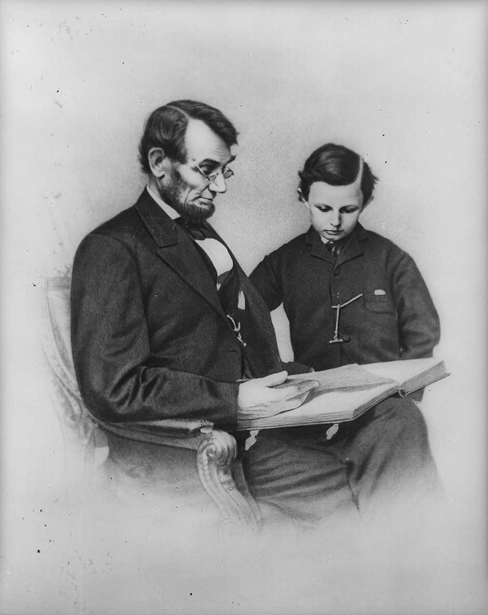

Example – people need to be able to depend on your leadership

Today, more than ever, people are looking for leaders who will lead by example in their dealings with people and their lifestyles.

Communication – people need to know what you are saying

Today, more than ever, people are looking for clarity and consistency in our written and oral communications. They are looking for honesty and openness in the dialogue they have with us as leaders.
Ability – you need to be capable of leading other people

Today, more than ever, people are looking for more than a slick appearance. They want content and proven ability they can trust to get them through the increasing challenges of the 21st Century.

Motivation – you need to know why you want to be a leader

Today, more than ever, people want to know why you are doing what you are doing and so do you! A simple ‘trust me’ won’t cut it. This is even more noticeable with the current crop of 16 – 24 year olds who are not so affectionately dubbed, “Generation WHY?”

Authority – people need to respond to your leadership

Today, more than ever, people want to be able to see demonstrated commitment and power in your decisions and authority in your actions.

Strategy – you need to know where you are going

Today, more than ever, people want to know you have a plan; one that is well thought out, covering all the contingencies and challenges. They want to know the details of that strategy before they agree to follow you.

Love and compassion – you need to care for the people around you

Today, more than ever, people want to know and see that you truly care about them, their needs, their concerns, their fears, their dreams, and their well-being. Lip service, hype, or idle words will not cut it on the 21st Century leadership track.

Take a serious look at your ‘current’ leadership skills in light of the above seven laws. Those you would hope to lead will be; and they are constantly judging your actions, attitudes, and motivation. What do you see? Are there areas where improvement is needed? When will you start and what will you do?

© Copyright 2015 Bob ‘Idea Man’ Hooey www.ideaman.net www.BobHooey.training
All rights reserved. Used with permission of the author.

Bob ‘Idea Man’ Hooey is a creative, productivity and leadership strategist who regularly writes for North American Consumer and Trade Journals, on-line magazines and company intranets. He works with Canada’s 50 Best Managed Companies. He is the prolific author of multiple business and leadership books and the 48th person in the history of Toastmasters International to earn their coveted professional level Accredited Speaker designation.

Articles may be copied or used for non-profit purposes, without the consent of the author, subject to the following being included: © Copyright 2015 Bob ‘Idea Man’ Hooey www.ideaman.net www.BobHooey.training All rights Reserved. Used with permission of the author.

